Pin 1..6 are connected to the Toshiba PHR-803T 3 coils.

However, it seems that only 1 coil is connected in a push-pull manner.

Apparently, this is sufficient for driving focus, and the other DOFs are needed for tracking and correcting the incident angle. It would be nice to have these other options too, so we don’t need to have the specimen exactly flat wrt the lens.

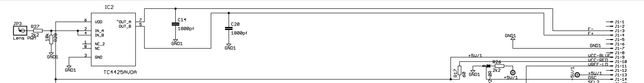

#define FSERVO_STEP_PIN 5 // Focus servo step pin

/**

** move_focus_servo() - Moves the lens of the pickup

**/

void move_focus_servo(uint8_t pos){

delay_us(3);

SET_OUTPUT(FSERVO_STEP_PIN);

if (pos == 0){

WRITE(FSERVO_STEP_PIN,LOW);

}

else if (pos == 255){

WRITE(FSERVO_STEP_PIN,HIGH);

}

else {

TCCR0A |= (1 << COM0B1);

OCR0B = pos;

}

}

Pin setting functions are from fastio.h